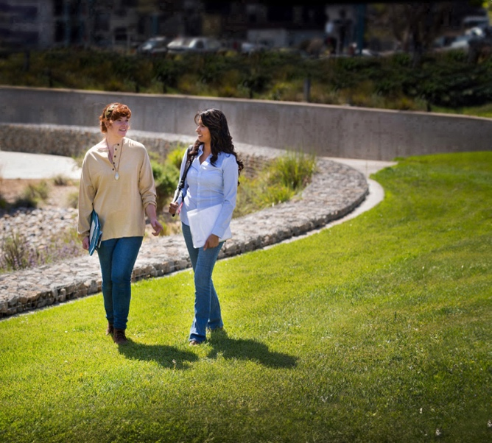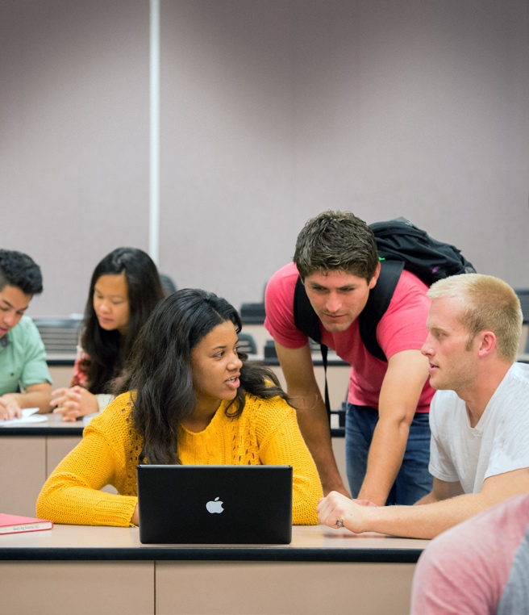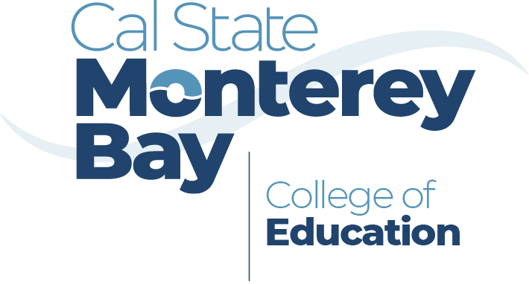

I love that HDFS   
provides the opportunity   
to pursue and explore many different fields by having a wide variety of courses available.

**Natalie Valdez, student**



csumb.edu/hdfs

**Contact Us**

**office phone**

000.000.0000



**office email**

xxx@csumb.edu



**office address**

123 Campus Center, Bldg. 00  
Seaside, CA 93955-8001



Human Development and Family Science

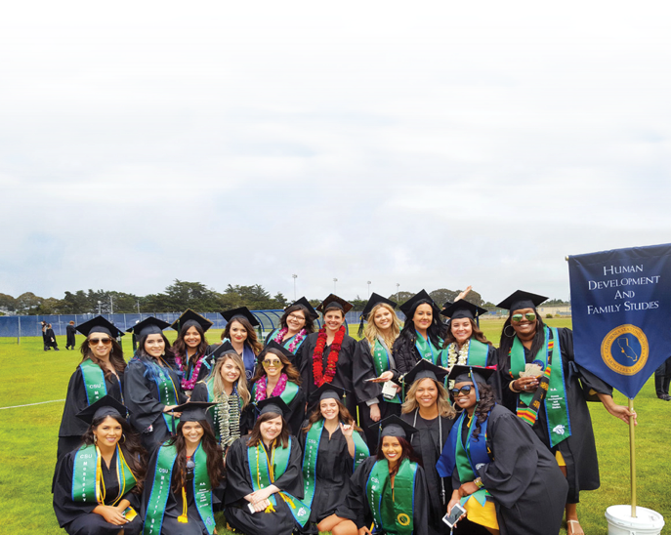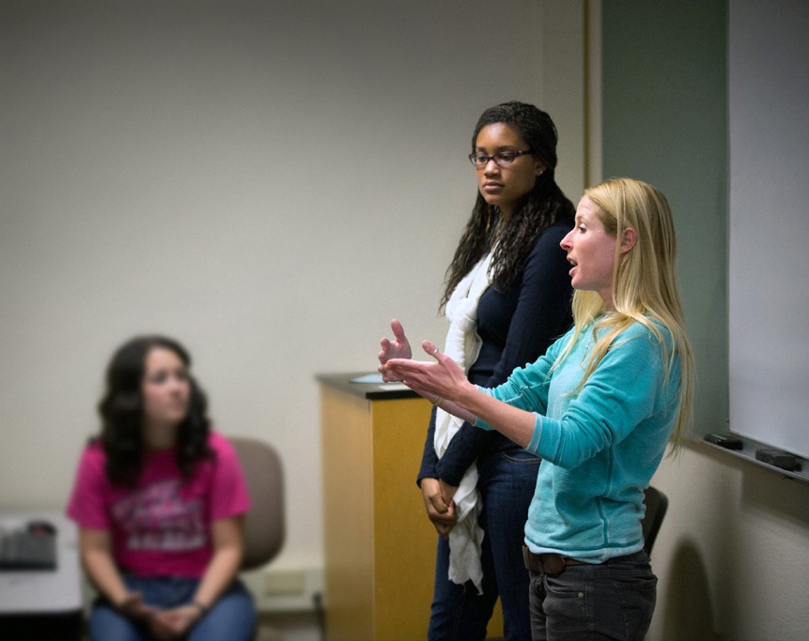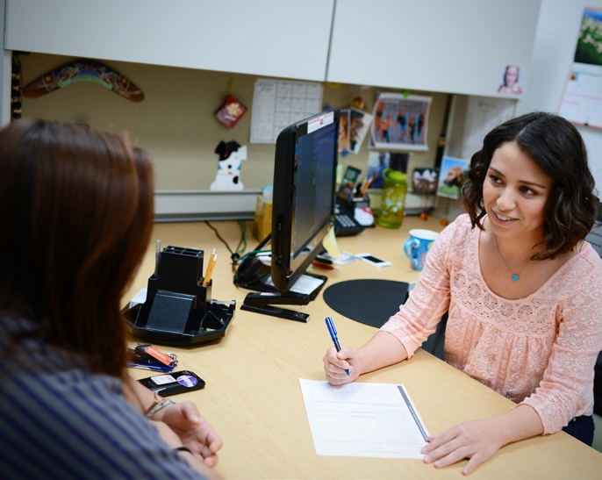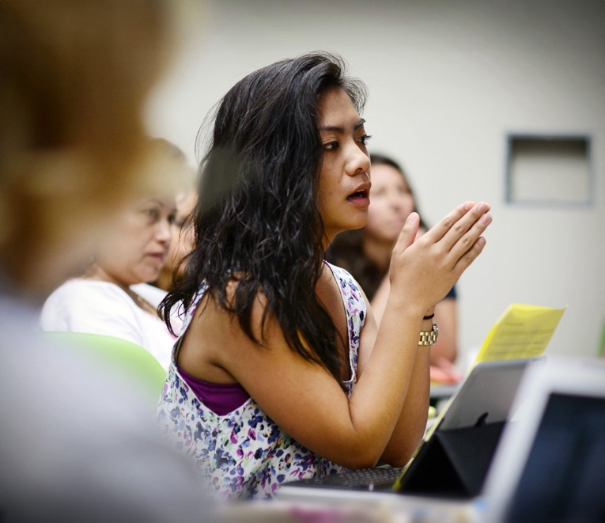

What is the Bachelor of Science in Human Development and Family Science (HDFS)?

The HDFS major focuses on human development from infancy through old age. Students will examine how family and community dynamics affect the development of individuals from a diverse range of backgrounds and life experiences.

The program accepts first-year students, transfers, and AS-T early childhood education and AA-T child and adolescent development certified students.

Program Features

• Courses offered day and evening

• Field-based service learning and partnerships in local schools

• Depth of study in one area (minor)

• Specialized, dedicated advising

• Small class sizes

**Career Paths**

The program is versatile and prepares students to work with children, youth, families, and elders in numerous professions. Possibilities to explore:

• Advocacy and Non-Profits

• Counseling and Social Work

• Early Intervention Services

• Education

• Health Services

• Preschool Teaching and Administration

• Research

Field Work Opportunities

CSUMB provides many opportunities for students to work in the field through service learning. Students will complete at least one service-learning course as part of the degree program, exploring career paths and learning which best fits them.