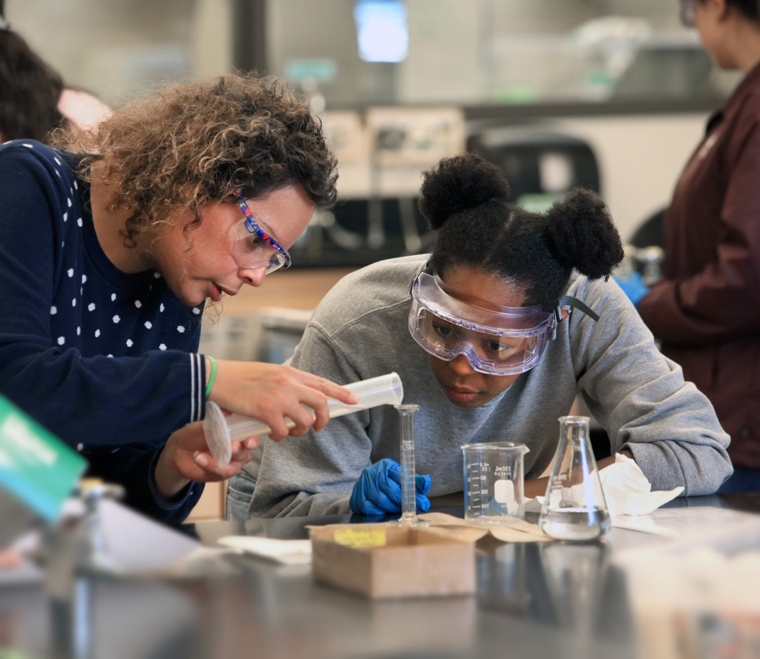

csumb.edu/trio

**STEM-Health Sciences**

**Apply online at  
csumb.edu/trio**

Applications are accepted   
on an ongoing, rolling basis.



**Contact Us**

**office phone**

000.000.0000



**office email**

xxx@csumb.edu



**office address**

123 Campus Center, Bldg. 00  
Seaside, CA 93955-8001



**official instagram**

csumb_triosss



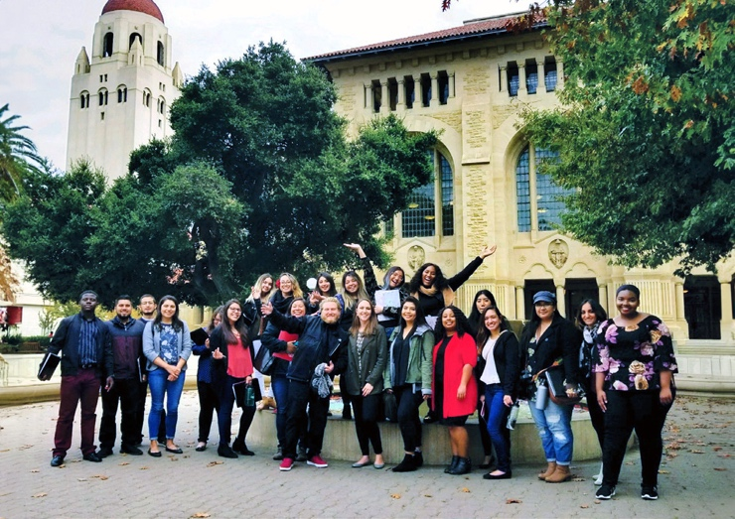

Mission

The TRIO Student Support Services (SSS) programs at CSUMB contribute to the success of first-generation, low-income students and students with disabilities by supporting and empowering participants in their academic, personal and professional growth.

Who Are We?

TRIO is a set of federally-funded college opportunity programs that support students from historically excluded backgrounds in their pursuit of a college degree. Founded in the 1960s, today there are over 3,000 TRIO programs serving students around the country. TRIO SSS has been at CSUMB since 2001 and has grown to two programs — TRIO SSS and TRIO SSS STEM-Health Sciences — supporting approximately 300 students every year.

Eligibility

To be eligible for the TRIO SSSprogram, participants must identify as at least ONE of the following:

• First-generation

• Low-income

• Documented disability



In TRIO there are   
nothing but positive influences… TRIO created the environment for me to develop the best of my capabilities as a student   
and leader.

Arturo Muñoz, HCOM



Services Provided

• 1:1 Advising and mentoring

• Academic support

• Financial literacy

• Financial aid assistance and information

• Grant aid for eligible students

• Cultural and social enrichment trips/activities

• Career preparation

• Graduate school exploration

• Summer Academy orientation

• Resources including computer lab, textbook loans and supplies

• Support and community!



TRIO SSS was my biggest support system throughout college and one of the reasons I have been successful. Being part of SSS is one of the best decisions that I have made throughout college.

Cecilia Garcia, Biology

