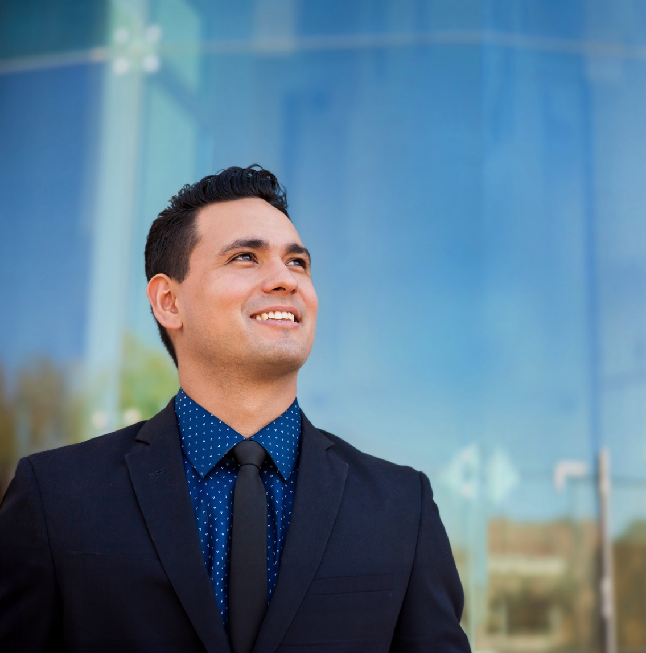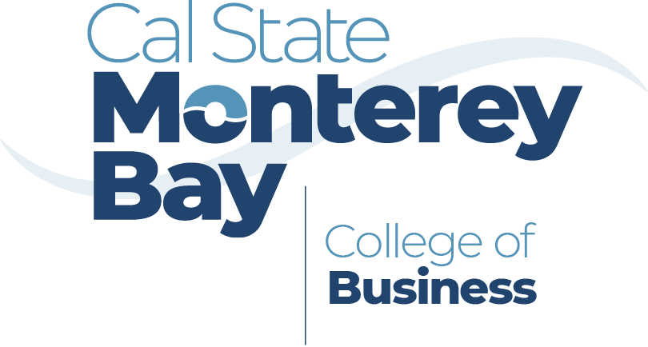

Developing Transformative and Responsible Leaders in Business

Developing Transformative and Responsible Leaders in Business

Developing Transformative and Responsible Leaders in Business

**office phone**

831.582.4232



**office email**

business@csumb.edu



**office address**

5108 Fourth Avenue  
Marina, CA 93933



Contact Us

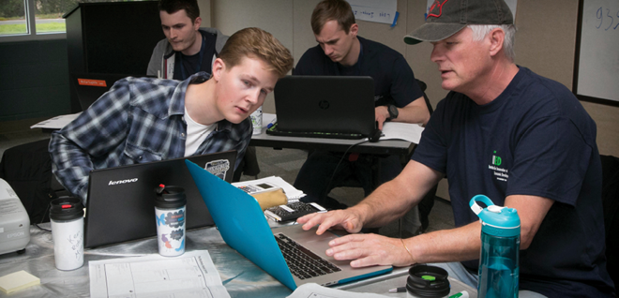

Our #1 priority is to help   
you achieve your career goals in the hospitality and tourism industry.

Dr. Paige Viren

Executive Director, Sustainable Hospitality Management Program

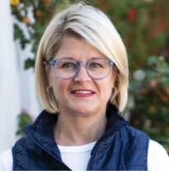

Why Our College Stands Out

The College of Business is a leader in business education. At CSUMB, our students learn to develop and transform businesses and nonprofits into modern community-focused organizations, achieving financial success while caring for human and environmental resources in an ethical and equitable manner.

csumb.edu/business

**office phone**

831.582.4232



**office email**

business@csumb.edu



**office address**

5108 Fourth Avenue  
Marina, CA 93933



Contact Us



Our #1 priority is to help   
you achieve your career goals in the hospitality and tourism industry.

Dr. Paige Viren

Executive Director, Sustainable Hospitality Management Program



Why Our College Stands Out

The College of Business is a leader in business education. At CSUMB, our students learn to develop and transform businesses and nonprofits into modern community-focused organizations, achieving financial success while caring for human and environmental resources in an ethical and equitable manner.

csumb.edu/business

**office phone**

831.582.4232



**office email**

business@csumb.edu



**office address**

5108 Fourth Avenue  
Marina, CA 93933



Contact Us



Our #1 priority is to help   
you achieve your career goals in the hospitality and tourism industry.

Dr. Paige Viren

Executive Director, Sustainable Hospitality Management Program



Why Our College Stands Out

The College of Business is a leader in business education. At CSUMB, our students learn to develop and transform businesses and nonprofits into modern community-focused organizations, achieving financial success while caring for human and environmental resources in an ethical and equitable manner.

csumb.edu/business