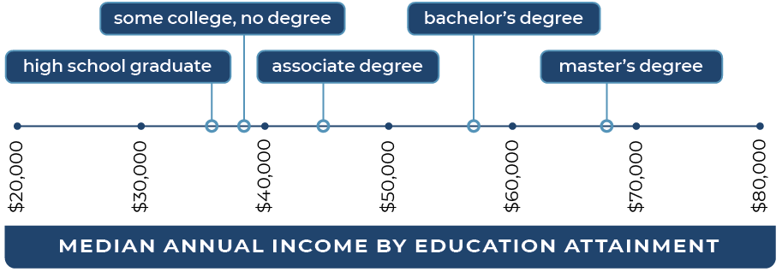

Types of Financial Aid

Federal Work Study

• Students work part-time on or off campus while enrolled

Grants

• Federal Pell Grant

• State University Grant (SUG)

• Federal Supplemental Educational Opportunity Grant (SEOG)

• Educational Opportunity Program (EOP)

• Middle Class Scholarship

• Cal Grant

• Students work part-time on or off campus while enrolled

Grants

Federal Pell Grant

• State University Grant (SUG)

• Federal Supplemental Educational Opportunity Grant (SEOG)

• Educational Opportunity Program (EOP)

• Middle Class Scholarship

• Cal Grant

Loans

• Direct Subsidized

• Loans (need based)

• Direct Unsubsidized Loans

• Direct Parent and Graduate PLUS Loans

Scholarships

• Applicants receive consideration for over 65 different scholarships with just one application

• Apply from Oct. 1 until the second week of February

• Letter of recommendation, unofficial transcripts, and personal statement required

Types of Financial Aid

Federal Work Study

• Students work part-time on or off campus while enrolled

Grants

• Federal Pell Grant

• State University Grant (SUG)

• Federal Supplemental Educational Opportunity Grant (SEOG)

• Educational Opportunity Program (EOP)

• Middle Class Scholarship

• Cal Grant

• Students work part-time on or off campus while enrolled

Grants

Federal Pell Grant

• State University Grant (SUG)

• Federal Supplemental Educational Opportunity Grant (SEOG)

• Educational Opportunity Program (EOP)

• Middle Class Scholarship

• Cal Grant

Loans

• Direct Subsidized

• Loans (need based)

• Direct Unsubsidized Loans

• Direct Parent and Graduate PLUS Loans

Scholarships

• Applicants receive consideration for over 65 different scholarships with just one application

• Apply from Oct. 1 until the second week of February

• Letter of recommendation, unofficial transcripts, and personal statement required

Types of Financial Aid

Federal Work Study

• Students work part-time on or off campus while enrolled

Grants

• Federal Pell Grant

• State University Grant (SUG)

• Federal Supplemental Educational Opportunity Grant (SEOG)

• Educational Opportunity Program (EOP)

• Middle Class Scholarship

• Cal Grant

• Students work part-time on or off campus while enrolled

Grants

Federal Pell Grant

• State University Grant (SUG)

• Federal Supplemental Educational Opportunity Grant (SEOG)

• Educational Opportunity Program (EOP)

• Middle Class Scholarship

• Cal Grant

Loans

• Direct Subsidized

• Loans (need based)

• Direct Unsubsidized Loans

• Direct Parent and Graduate PLUS Loans

Scholarships

• Applicants receive consideration for over 65 different scholarships with just one application

• Apply from Oct. 1 until the second week of February

• Letter of recommendation, unofficial transcripts, and personal statement required



Resources

CSUMB Financial Aid

• General Information  
csumb.edu/financialaid

• Scholarships  
csumb.edu/financialaid/scholarships

• Financial Literacy  
sites.google.com/csumb.edu/finacialliteracy/home

**Federal Student Aid**

• 1.800.433.3243

• Free Application for Federal Student Aid (FAFSA) **studentaid.gov**

• CSUMB FAFSA School Code **032603**

California Aid and More

• Cal Grant Website  
csac.ca.gov

• California Student Aid Commission  
1.888.224.7268

• Dream Act Application  
dream.csac.ca.gov/landing

• External Scholarships  
fastweb.com

• Loan Payment Calculator  
finaid.org/calculators/loanpayments

Timeline

October

• Submit FAFSA or Dream Act application online

• CSUMB Scholarship application period opens

February

• CSUMB Scholarship

application deadline

• Submit additional documents to Financial Aid Office (if requested)

March

• Priority deadline is March 2 for FAFSA or Dream Act applications

• Estimated financial aid award notifications sent

• Financial aid notifications for first-time freshmen and transfer students

May

• CSUMB Scholarship recipients notified

**office phone**

831.582.5100



**office email**

financial_aid@csumb.edu



**office address**

5283 Sixth Avenue  
Seaside, CA 93955-8001



**office hours**

Monday–Friday, 9am–4pm



Contact Us

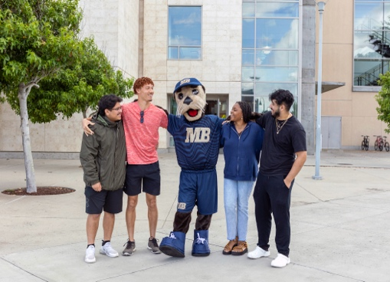

Resources

CSUMB Financial Aid

• General Information  
csumb.edu/financialaid

• Scholarships  
csumb.edu/financialaid/scholarships

• Financial Literacy  
sites.google.com/csumb.edu/finacialliteracy/home

**Federal Student Aid**

• 1.800.433.3243

• Free Application for Federal Student Aid (FAFSA) **studentaid.gov**

• CSUMB FAFSA School Code **032603**

California Aid and More

• Cal Grant Website  
csac.ca.gov

• California Student Aid Commission  
1.888.224.7268

• Dream Act Application  
dream.csac.ca.gov/landing

• External Scholarships  
fastweb.com

• Loan Payment Calculator  
finaid.org/calculators/loanpayments

Timeline

October

• Submit FAFSA or Dream Act application online

• CSUMB Scholarship application period opens

February

• CSUMB Scholarship

application deadline

• Submit additional documents to Financial Aid Office (if requested)

March

• Priority deadline is March 2 for FAFSA or Dream Act applications

• Estimated financial aid award notifications sent

• Financial aid notifications for first-time freshmen and transfer students

May

• CSUMB Scholarship recipients notified

**office phone**

831.582.5100



**office email**

financial_aid@csumb.edu



**office address**

5283 Sixth Avenue  
Seaside, CA 93955-8001



**office hours**

Monday–Friday, 9am–4pm



Contact Us



Resources

CSUMB Financial Aid

• General Information  
csumb.edu/financialaid

• Scholarships  
csumb.edu/financialaid/scholarships

• Financial Literacy  
sites.google.com/csumb.edu/finacialliteracy/home

**Federal Student Aid**

• 1.800.433.3243

• Free Application for Federal Student Aid (FAFSA) **studentaid.gov**

• CSUMB FAFSA School Code **032603**

California Aid and More

• Cal Grant Website  
csac.ca.gov

• California Student Aid Commission  
1.888.224.7268

• Dream Act Application  
dream.csac.ca.gov/landing

• External Scholarships  
fastweb.com

• Loan Payment Calculator  
finaid.org/calculators/loanpayments

Timeline

October

• Submit FAFSA or Dream Act application online

• CSUMB Scholarship application period opens

February

• CSUMB Scholarship

application deadline

• Submit additional documents to Financial Aid Office (if requested)

March

• Priority deadline is March 2 for FAFSA or Dream Act applications

• Estimated financial aid award notifications sent

• Financial aid notifications for first-time freshmen and transfer students

May

• CSUMB Scholarship recipients notified

**office phone**

831.582.5100



**office email**

financial_aid@csumb.edu



**office address**

5283 Sixth Avenue  
Seaside, CA 93955-8001



**office hours**

Monday–Friday, 9am–4pm



Contact Us

