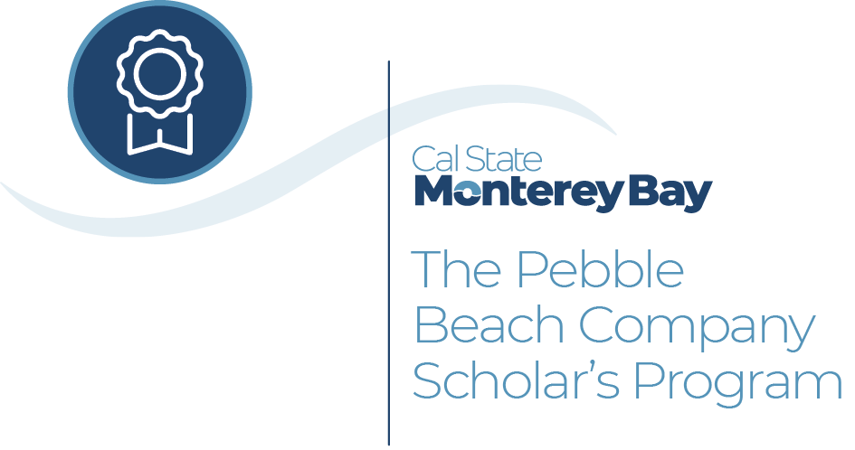

csumb.edu/business/scholars

The Pebble Beach   
Company Scholar Program

The Pebble Beach Company Scholar’s Program is the latest partnership between The Pebble Beach Company and Cal State Monterey Bay’s Sustainable Hospitality Management Program. It is designed to bridge college degrees and real-world careers by supporting and training the next generation of hospitality professionals.

Program

The program provides students with the following:

• $5,000 scholarships for tuition, books or housing;

• Paid internships and housing benefits;

• Program advisors to keep scholars on track;

• Valuable experience with a world-class hospitality company and iconic events such as Concours d’Elegance and USGA tournaments;

• Certifications and training programs to help jump-start careers.

Selection Criteria

Pebble Beach Company Scholars must meet these standards:

• Maintain a 3.0 or higher GPA

• Serve as ambassadors for CSUMB and PBC

• Participate in a leadership club on campus

• Show an interest in hospitality and in working for PBC during and after college

Application Process

Applicants must be in the Sustainable Hospitality Management program and submit: an online Scholars program application, including academic transcripts, resume and a statement of purpose; two faculty recommendations; and a leadership portfolio in the form of an essay.

csumb.edu/business/scholars

The Pebble Beach   
Company Scholar Program

The Pebble Beach Company Scholar’s Program is the latest partnership between The Pebble Beach Company and Cal State Monterey Bay’s Sustainable Hospitality Management Program. It is designed to bridge college degrees and real-world careers by supporting and training the next generation of hospitality professionals.

Program

The program provides students with the following:

• $5,000 scholarships for tuition, books or housing;

• Paid internships and housing benefits;

• Program advisors to keep scholars on track;

• Valuable experience with a world-class hospitality company and iconic events such as Concours d’Elegance and USGA tournaments;

• Certifications and training programs to help jump-start careers.

Selection Criteria

Pebble Beach Company Scholars must meet these standards:

• Maintain a 3.0 or higher GPA

• Serve as ambassadors for CSUMB and PBC

• Participate in a leadership club on campus

• Show an interest in hospitality and in working for PBC during and after college

Application Process

Applicants must be in the Sustainable Hospitality Management program and submit: an online Scholars program application, including academic transcripts, resume and a statement of purpose; two faculty recommendations; and a leadership portfolio in the form of an essay.

csumb.edu/business/scholars

The Pebble Beach   
Company Scholar Program

The Pebble Beach Company Scholar’s Program is the latest partnership between The Pebble Beach Company and Cal State Monterey Bay’s Sustainable Hospitality Management Program. It is designed to bridge college degrees and real-world careers by supporting and training the next generation of hospitality professionals.

Program

The program provides students with the following:

• $5,000 scholarships for tuition, books or housing;

• Paid internships and housing benefits;

• Program advisors to keep scholars on track;

• Valuable experience with a world-class hospitality company and iconic events such as Concours d’Elegance and USGA tournaments;

• Certifications and training programs to help jump-start careers.

Selection Criteria

Pebble Beach Company Scholars must meet these standards:

• Maintain a 3.0 or higher GPA

• Serve as ambassadors for CSUMB and PBC

• Participate in a leadership club on campus

• Show an interest in hospitality and in working for PBC during and after college

Application Process

Applicants must be in the Sustainable Hospitality Management program and submit: an online Scholars program application, including academic transcripts, resume and a statement of purpose; two faculty recommendations; and a leadership portfolio in the form of an essay.