Wash Your Hands

# HEALTH LOOKOUT

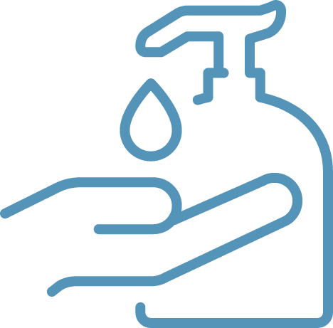to help prevent the spread of COVID–19

# Small Steps Make a Big Difference

Follow the Centers for Disease Control and Prevention best practices and all health guidelines, including:   
stay home if you are sick, wash your hands frequently, wear a mask, stay at least 6 feet away from others.