Finance Data Warehouse upgrade-changes and Enhancements

- The ”Apply” button will appear on some dashboards, please ignore this button.

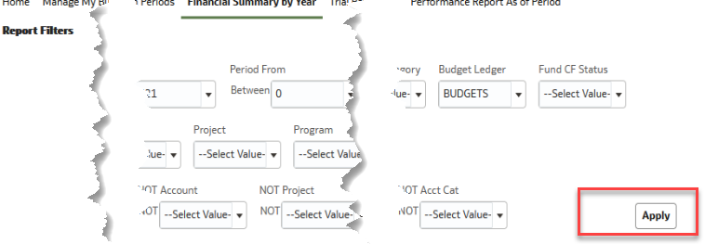

- The Search feature on the filters has changed *YAY*
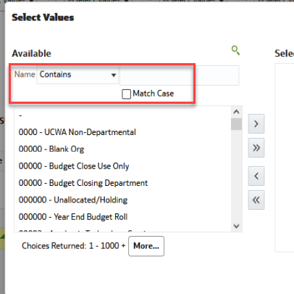

- You can also start a search by typing in the report filter
- 