CFS 9.2 MP 5.0 Frequently Asked Questions (FAQ)

1. **What does the MP 5.0 upgrade include?**

* PeopleTools Upgrade from 8.57.11 to 8.59.07
* PeopleSoft Image Update from #34 to #41

1. **What are the key dates of the MP 5.0 implementation?**

|  |  |  |  |
| --- | --- | --- | --- |
|  | MP 5.0 | Date | Time |
|  | Campus Development Database Available (FBCFSDVA) | Late April early May 2022 |  |
|  | Campus Development Phase | May to  August 2022 |  |
|  | Campus BI Publisher Check Templates Due -  Details to be provided during the call on future call | TBD |  |
|  | Campus COMR to be included in the MP 5.0 packaging – Queries, Interfaces, and Security | August 26, 2022 |  |
|  | MP 5.0 Review Call | September 19, 2022 | 11:00 am – 12:00 pm |
|  | MP 5.0 Presentations | September 20, 2022 | 10:00 am – 12:00 pm |
|  | User Acceptance Testing | September 19 to  October 28, 2022 |  |
|  | User Acceptance Testing Q & A Calls  Call # 1  Call # 2 | October 13, 2022  October 20, 2022 | 11:00 am – 12:00 pm  11:00 am – 12:00 pm |
|  | User Acceptance Testing Sign-off deadline | October 31 to November 2, 2022 |  |
|  | Test Scripts must be completed and uploaded to CFS 9.2 Application Site in the CFS 9.2 Campus Documentation Folder | October 31 to  November 7, 2022 |  |
|  | Move to Production | November 18 to November 21, 2022 |  |
| 1. The system will be unavailable | From  November 18, 2022 | 5:00 pm |
| Until  November 21, 2022 | 9:00 am or earlier |
|  | MP 5.0 Go-Live | November 21, 2022 | 9:00 am or earlier |

1. **For the Maintenance Pack (MP) development, are we required to submit a COMR for all campus queries, interfaces, and security?**

* No, you only need to submit a COMR if a retrofit is needed. If there is no change in the queries, interfaces, or security, a COMR is not needed. For migration purposes, the App Designer project should only contain the objects that are changed for MP 5.0
* All existing queries, interfaces, and security will be carried over to MP 5.0.

1. **What objects do campuses need to review and retrofit during the campus development phase?**

* Queries – Invalid queries should be deleted or retrofitted
* Approved Interfaces – These interfaces were developed by campuses and not delivered by CMS Central. Approved interfaces are currently included in CFS 9.2 production
* Security – Campus security objects such as menu changes, new components, etc.

1. **What is the campus’ MP 5.0 development process flow for the CFS 9.2 Maintenance Pack?**

The following databases will be used during the development process



* Retrofit queries, interfaces, and security in F**B**CFSDVA and perform Unit Testing
* After development is finalized, developers will package the objects in F**B**CFSDVA and submit a COMR request to CMS through a Service-Now ticket using the following identifiers. One ticket for FCFSPRE for the User Acceptance Testing. One ticket for FCFSPRD for production go-live.
  + **Type**: Request
  + **Category**: CMS Migration Services
  + **Subcategory**: COMR-CFS
  + **CMS** **Release**: CFS 9.2 MP 5.0
* It is recommended that queries, interfaces, and security are packaged separately

1. **Do campuses need to change the BI Publisher check templates?**

* There is a maximum of one check template for each campus.
* We recommend campuses to test campus BI Publisher Check templates(s) with Wells Fargo. Testing instructions and a test database will be provided to campuses. Campuses are required to adjust BI Publisher check template(s) if bank verification fails.
* For any logo or signature changes, AP Check Configuration can be used without modifying the check template(s).
  + **Navigation** – CSU Administer Integration > CSU AP Administration > CSU AP Check Configuration
* Database F**B**CFSCNV will be available for campus retrofit and testing. Additional information will be forthcoming.
* To retrofit check template(s), BI Publisher add-in version 12.2.1.4 is required. The installation guide has been posted to the CFS 9.2 site.
  + **Site Link:** <https://csyou.calstate.edu/Projects-Initiatives/CMS/AppDevelopment/CMSCFS92/Pages/CFS92Home.aspx> Text, shape

    Description automatically generated

1. **Can I use Windows 7 to print AP checks?**

* Windows 7 is no longer supported by Microsoft starting January 2020. Windows 10 is recommended and supported for the check print process only.

1. **How do I log a ticket related to MP 5.0 User Acceptance Testing errors?**

* In the Short description, specify CFS 9.2 MP 5.0 Testing and add a brief description
  + **Type**: Issue / Problem
  + **Category**: CMS-CFS
  + **Subcategory**: <Select an appropriate module>
  + **CMS Release**: CFS 9.2 MP 5.0

1. **Where are the Integration Broker User Guides?**

* Integration Broker Guides – Guide will be updated for PT 8.59.07
  + **Site Link:** <https://csyou.calstate.edu/Projects-Initiatives/CMS/AppDevelopment/CMSCFS92/Pages/CFS92General.aspx>

1. **Can you provide a list of scheduled jobs that are not running in FCFSPRE?**

* None. Job scheduling will be turned on in PRE and all jobs that run in PRD are active in PRE.

1. **Where do I sign off the MP 5.0 Acceptance Testing?**

* The sign-off document will be posted during the User Acceptance Testing period
* You can access the CFS Migration Sign-off Forms page using the link below:
  + **Site Link:** <https://csyou.calstate.edu/groups/IS/Applications/CFS/CFSAuditInfo/CFS%20Migration%20Signoff%20Forms/Forms/AllItems.aspx>
* Open the ***CFS 9.2 MP 5.0 Sign-off*** document
* Sign your name, date, and SAVE the document. If you are a delegate or a delegate designee and have access issues, follow the online instructions to request access

1. **Where do I load the completed MP 5.0 Acceptance Test Scripts?**

* Manual Navigation: CSYou Home > Projects & Initiatives > Common Management Systems (CMS) > Applications > CFS 9.2. Under the Related Links, select CFS 9.2 Campus Documentation > CFS 9.2 MP 5.0 – Campus Acceptance Test Scripts
  + **Site Link:** <https://csyou.calstate.edu/groups/IS/Projects/CFS92Upg/CFS%2092%20Campus%20Documentation/Forms/AllItems.aspx>
  + Select folder CFS 9.2 MP 5.0 – Campus Acceptance Test Scripts

1. **Do we need to inactivate Integration Broker (IB) prior to the MP 5.0 Upgrade?**

* Yes. It is recommended. During the CFS downtime there are no IB outbound transactions as CFS application server is down. For inbound transactions from CS/HR, campuses are advised to PAUSE the CFS queues in CS/HR. If you don’t wish to pause the queue, please note that the messages will stay in ‘Error’, and once CFS is up you have to ‘Resubmit’ them.
* Please do not inactivate the CFS Node as all routings will be set to ‘Inactive’ status
  + **Navigation** – PeopleTools > Integration Setup > Queues

C:\Users\mnorton\AppData\Local\Temp\SNAGHTML726c5b.PNG

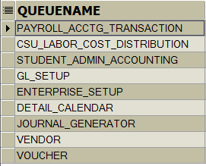

1. **Why am I not able to log in using Chrome/Firefox/Edge/IE?**

* When testing their new upgraded databases, users may find that they are unable to log into a particular database using one browser, but if they use a different browser, they have no problem. The appearance of the error varies. Sometimes it is a message that the browser can't reach the site, or the page can't be displayed. Other times it appears to be a security error, and sometimes it's just a blank page with a spinning cursor. When this happens, we recommend that the user clear the local browser cache, close all windows for that browser and then try again.
* Alternating between different Tools versions in the same browser seems to cause issues that can only be resolved by clearing the browser cache. After clearing the cache, you can try using one browser for your CFS92/PT 8.57.11 instances and a different browser for your CFS92/PT 8.59.07 instances. For instance, you may use Chrome for 8.57 and Firefox for 8.59. It may still be necessary to occasionally clear cache, however the frequency should be reduced.

1. **Using the same browser, I open multiple sessions and log into different instances on the same PeopleTools version.  When I try to navigate to pages, I am brought back to the log-in screen.  How do I prevent this from happening?**

* Because the same browser is used, cookies are causing the conflict.  Use different browsers to log into different instances, even if they are on the same PeopleTools version

1. **How do I navigate in MP 5.0?**

**Homepage enhancements:**

|  |
| --- |
|  |

**Global Search Bar:** Now appears at the center of the banner at the top of the Homepage.

|  |
| --- |
|  |

**Homepage Selector:** Previously, located in the center of the homepage, the Homepage selector has moved to the top-left. Use this drop-down to view and/or select your desired homepage. Or use, the new Next and Previous buttons located at the top-right, to scroll through available homepages.

|  |
| --- |
|  |

**Quick Access Bar:** On the left of the Homepage, a quick access bar is included which provides one-click access to your favorites and most recently visited items.

|  |  |
| --- | --- |
|  | Recently Visited    Favorites |

**Fluid Interface icons in the upper-right corner of the Homepage**

|  |  |
| --- | --- |
|  | |
| Home Button | Use to return to the system-defined default homepage, which is the homepage that you arrive at immediately upon sign-on |
| Notifications | Displays the notification window showing any pending actions or alerts |
| Actions | Use to display the Actions List. The “Sign Out” link can be found under here. |
| NavBar | Use to display the navigation bar (NavBar).  After pressing the Navigation Bar button, the NavBar side page appears. Use this page to access additional navigational options:    MP 5.0  MP 4.0    **MP 5.0 New Icon design**  In a fluid environment, the Navigator displays the traditional menu structure as the user would see when accessing PeopleSoft in classic mode and using the Main Menu |

**Personalize Homepage:**  Available homepages can be personalized to suit your needs. For homepages that have not been personalized, the Personalize Homepage link will appear in the center of the page, click on the link to view personalization options.

|  |
| --- |
|  |

1. **What browsers are certified for use with PeopleTools 8.59? What versions of MS Word/Excel are certified for use with PeopleTools 8.59?**

* As of February 11, 2022, the following browsers and MS word/excel (64-bit) versions are certified for use with PeopleTools 8.59.

|  |  |  |
| --- | --- | --- |
| Certified With | Number of Releases / Versions | Note |
| Microsoft Internet Explorer | 1 Release(11) | As of June 15, 2022, Microsoft will retire the browser. |
| Apple Safari | 1 Release(14) |  |
| Google Chrome | 1 Release(89) |  |
| IBM DB2 Client | 1 Release(11.1) |  |
| IBM DB2 Connect | 1 Release(89) |  |
| Microsoft Edge (Chromium) | 4 Releases(2019,2016,2013,365) |  |
| Microsoft Excel | 1 Release(11) |  |
| Microsoft Internet Explorer | 3 Releases(2019,2017,2016) |  |
| Microsoft SQL Server Client | 3 Releases(2019,2016,2013) |  |
| Microsoft Word | 2 Releases(87 RR,78.9 ESR) |  |
| Mozilla Firefox | 1 Release(14) |  |

1. **When opening a browser compare report using Firefox, Chrome, or MS Edge, why is the report blank?**

June 16, 2022

* In the latest versions of Firefox/Chrome/Edge browsers, accessing local files is prevented by the new security feature CORS (Cross Origin Resource Sharing).
* Fix is expected in PeopleTools 8.60.
* PeopleTools 8.58.18 and 8.59.08 and higher the browser compare reports will include the PeopleTools Compare Viewer tool pscmpviewer.exe

* Two available work arounds:
  + - 1. **First Preference, Use Microsoft Edge**
         1. Use Edge and “Reload in IE Mode”

Click Edge browser icon

Once the browser window appears, on the top right of the window, click on the “…” (settings)



**Continue…**

The setting prompt will appear, then select “Reload in Internet Explorer mode”

Continue…

If the “Reload in Internet Explorer mode” option is not active, perform the following steps and then repeat the first step.

Continue …

If the setting is managed by the campus admins, then users cannot change the settings.  If it’s currently “Don’t Allow”, then the user should contact their campus administrator to change it to “Allow.”

* + - 1. **For Chrome and Microsoft Edge**

1. **What CFS databases are available for the CS/HR/CHRS PeopleTools 8.59.07 Testing?**

* **For current Production (PT 8.57.11)**
  + Database and date TBD
* **For MP 5.0 (PT 8.59.07)**
  + Database and date TBD

1. **Do we need to load the FDW Test Scripts to the CFS 9.2 site?**

* Yes, all completed test scripts shall be uploaded to the CFS 9.2 website.
  + **Site Link:** <https://csyou.calstate.edu/groups/IS/Projects/CFS92Upg/CFS%2092%20Campus%20Documentation/Forms/AllItems.aspx>
* **Manual Navigation:** CSYou Home > Projects & Initiatives > Common Management Systems (CMS) > Applications > CFS 9.2. Under the Related Links section, click CFS 9.2 Campus Documentation hyperlink and select the CFS 9.2 MP 5.0 – Campus Acceptance Test Scripts folder.

1. **In preparation for the MP 5.0 Move to Production, are there any baseline queries we can use as references for data clean-up?**

* The following queries are a valuable tool during Month-end / Year-End / Upgrades
* They facilitate the process by identifying sub-system transactions that need attention
* They help to ensure that transactions requiring further processing and/or closure in the current period are finalized.
* **General Ledger**

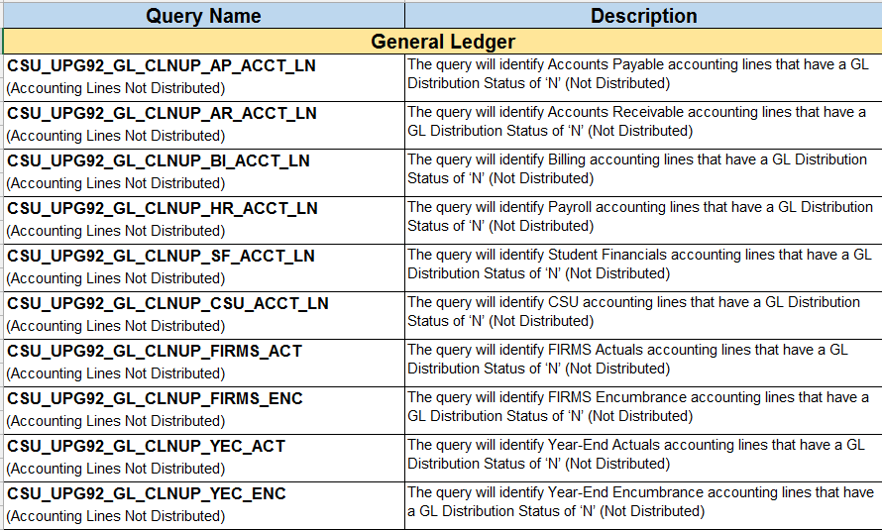

* **Accounts Payable**

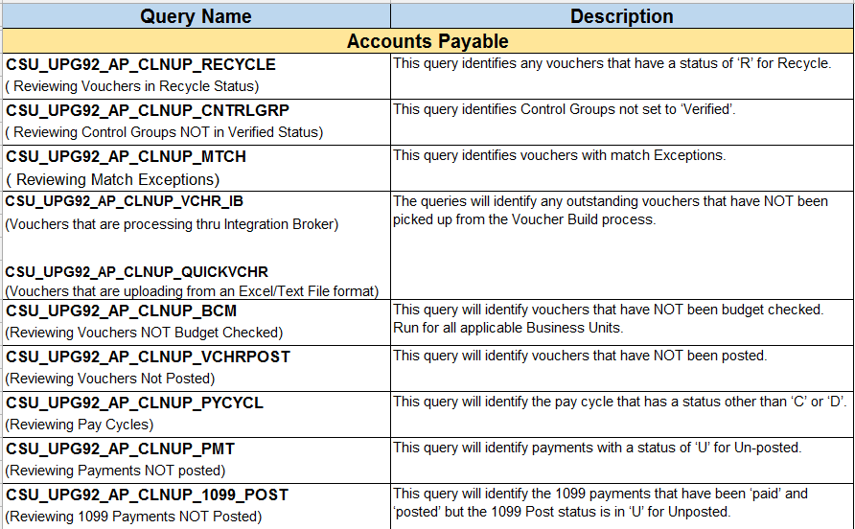

* **Purchasing**

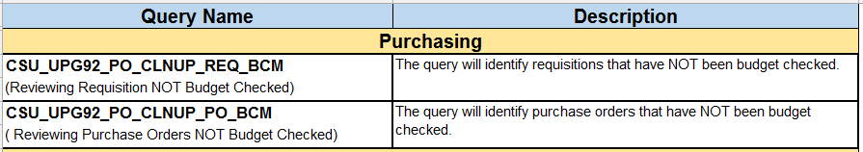

* **Asset Management**

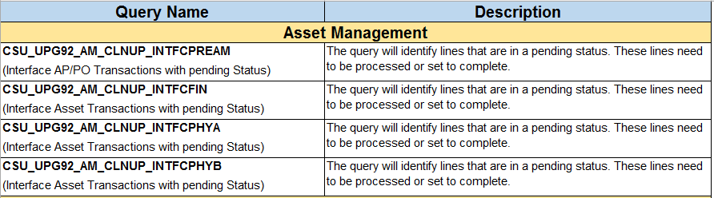

* **Accounts Receivable / Billing**

1. **When I view a page, some fields appear to be wrapping or not aligned.**

* Classic Plus was introduced as a mean to unify the look and feel of classic components to Fluid pages.
* All CSU custom pages have been converted to Classic Plus in which some pages may display fields that appear to wrap or are not aligned.
  + The design of the page or process continues to function. CMS will revisit these pages with styling issues later.

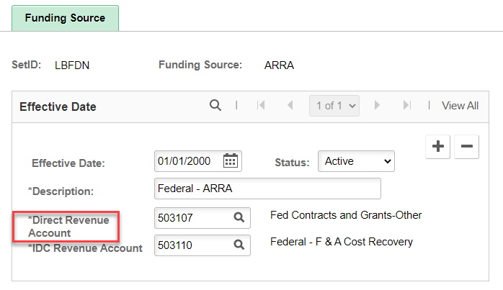

1. **When I view a page, some buttons appear to overlap.**

* This is not page or browser specific.
* The example below: Chrome browser was set to 90%.

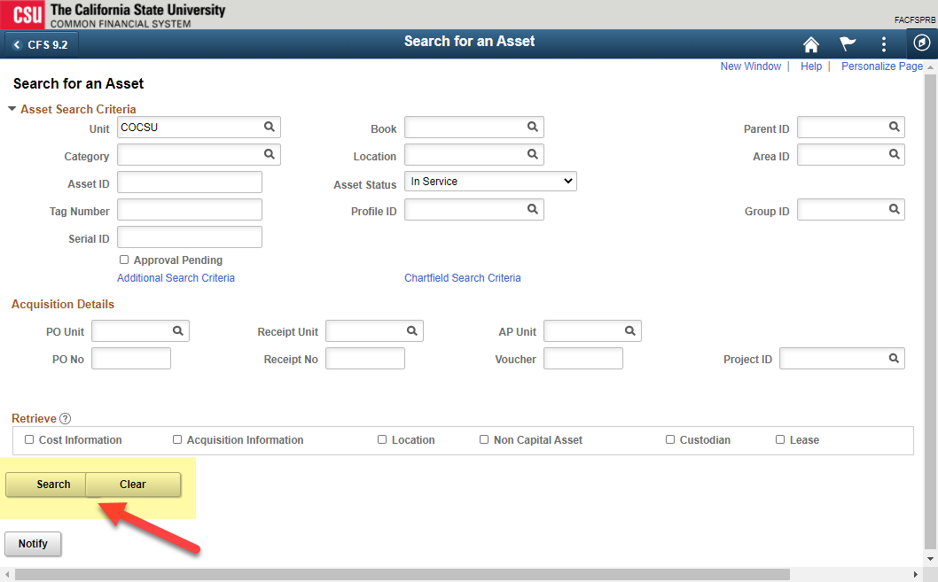

* On the browser, ensure that the Zoom is set to 100%
  + Using the keyboard to manually adjust the Zoom, hold the **Ctrl** key down and use the “+” (increase) or “-” (decrease).
  + Using the mouse with a wheel, hold the **Ctrl** key down and use the wheel to zoom in or out.
* The example below: Chrome browser was set to 100%.

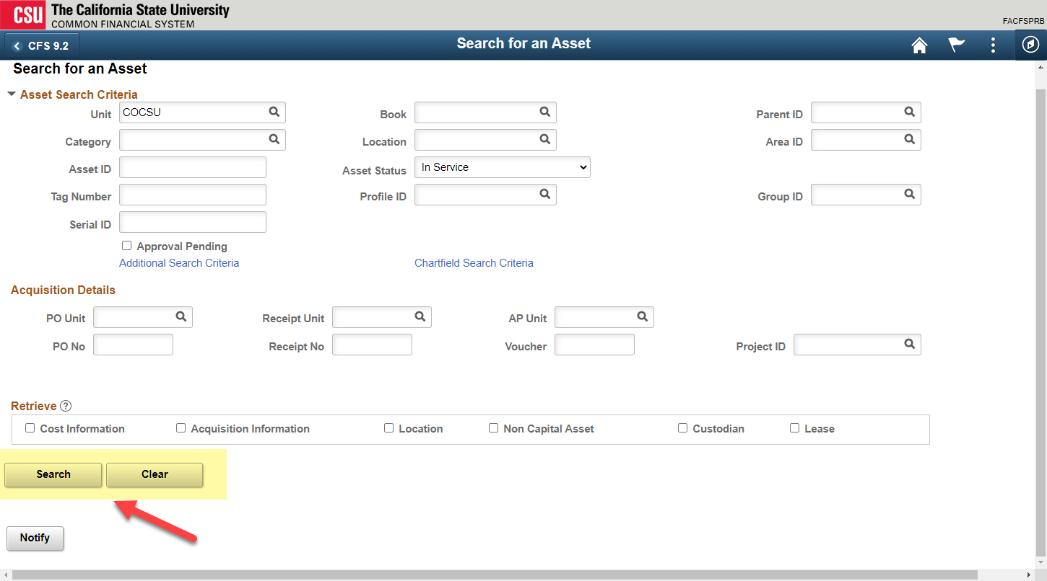

1. **Why does my schedule query continue to error out?**

* During the upgrade, many records were updated. These updated records may be associated with private and public queries that require repairing.
* Using Query Manager, queries are automatically repaired when opened. The user or campus query administrator can perform this update.
  + **Navigation**: NavBar > Reporting Tools > Query > Query Manager

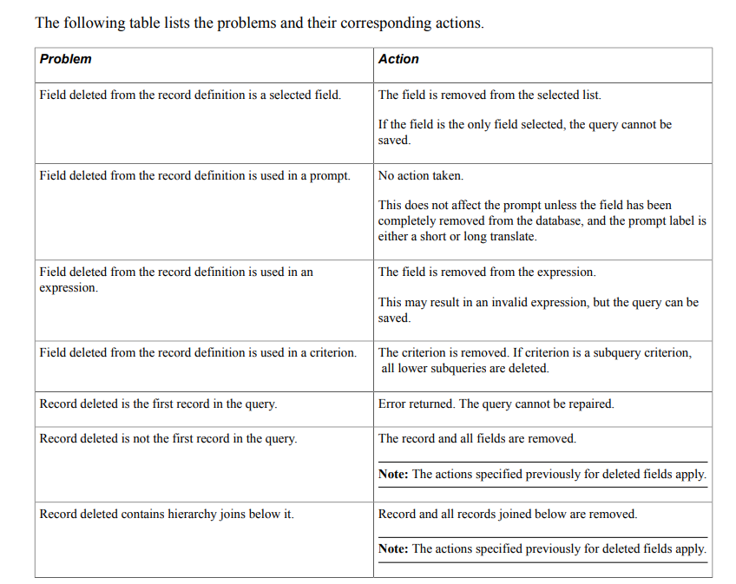

1. **The columns field name and input box on the grid are not aligned.**

* This is not page specific.

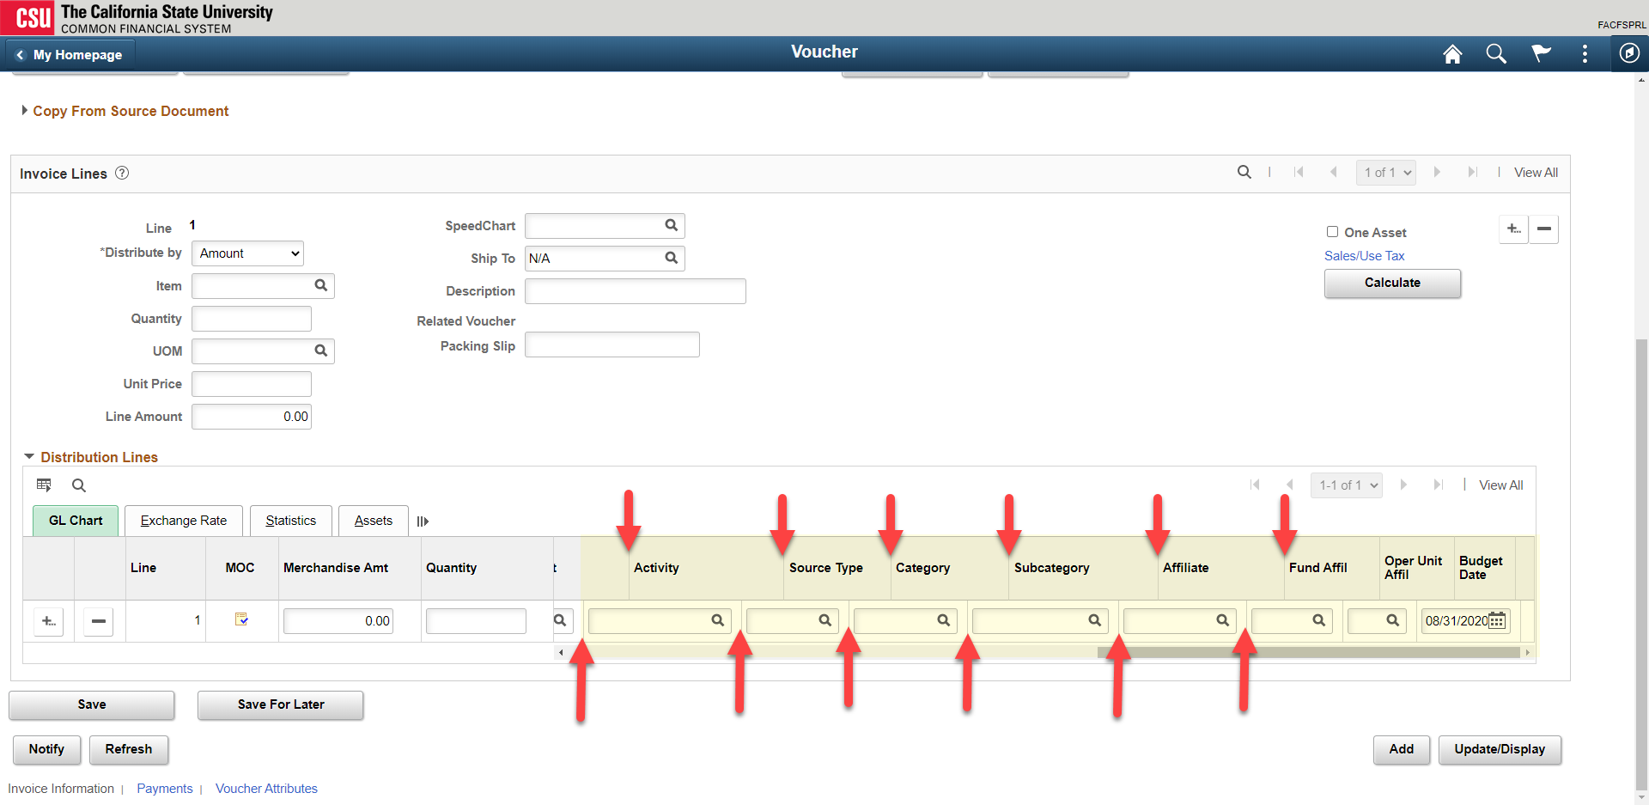

* To minimize the misaligned columns, perform the following steps:
  + Personalize grid (one-time action) by clicking on the **Grid Action Menu** icon > Personalize

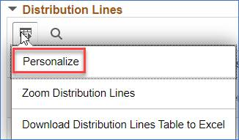

* + Continue…
  + The Grid Customization prompt will appear:

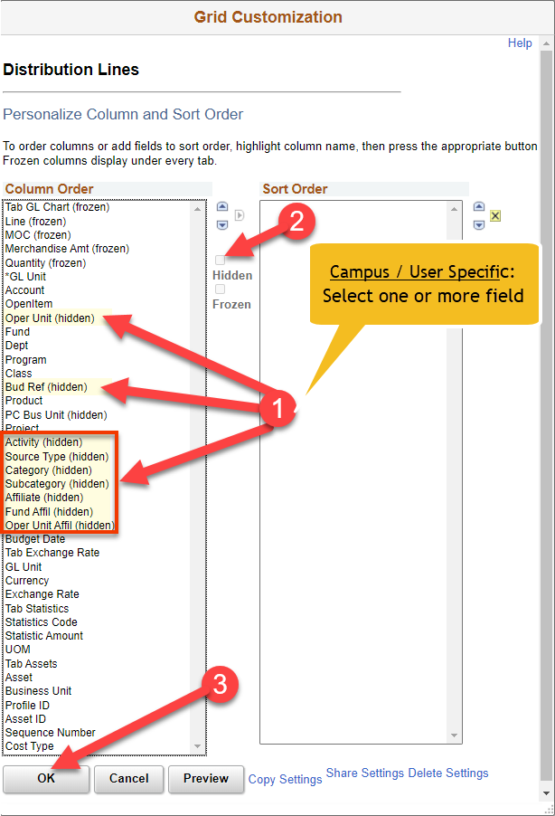

* + Continue …
  + Click on the **Show all columns** icon to expand all columns

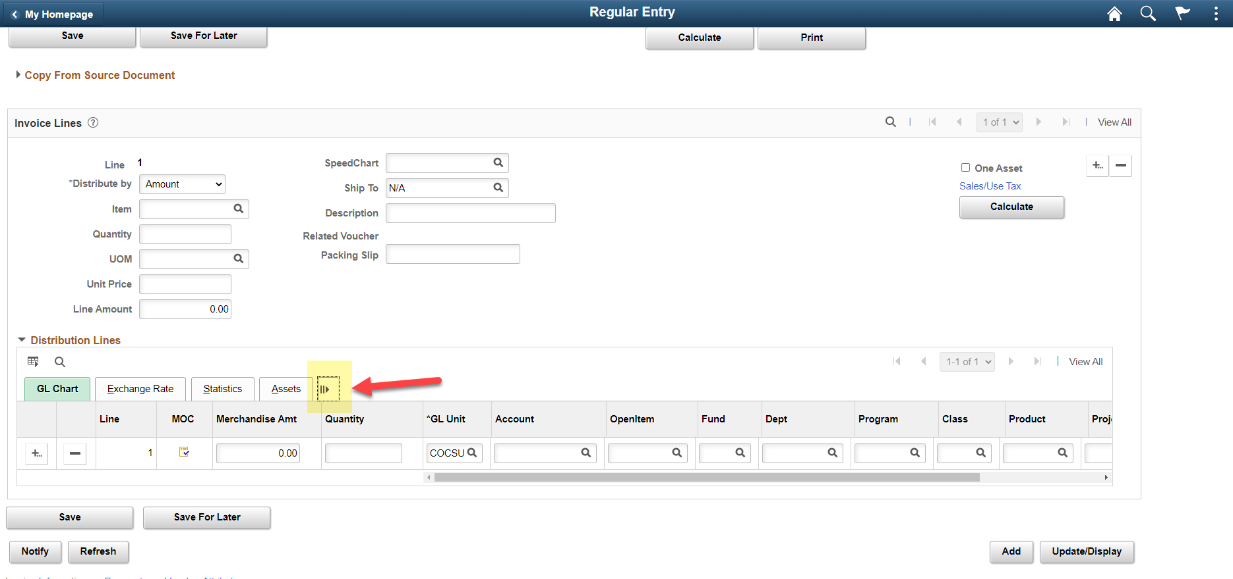

* + Column headings and field input are in alignment.

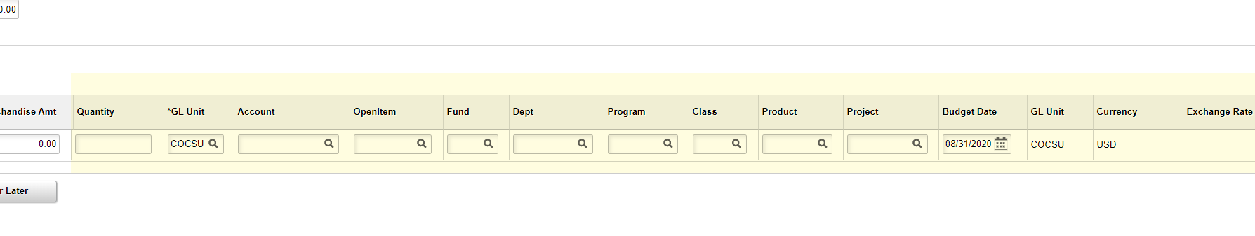

1. **On occasion, while navigating within the application, the NavBar icons will appear misaligned.**

* The function of the icons is not affected**.**

* When misalignment of icons appears, click on the Home button to restore the alignment of icons.



1. **New menu order options: Users have the option to change the menu order by clicking on the sprocket located at the top-right of the NavBar to change it either Standard or Alphabetical order.**

* Some Oracle/PeopleSoft menu labels have changed.

|  |
| --- |
|  |

**Standard Order:**  The CSU menu navigation uses the Standard menu order.

|  |  |
| --- | --- |
|  |  |

**Alphabetical Order:**

|  |  |
| --- | --- |
|  |  |

1. **Menu breadcrumbs 2.0: While navigating, breadcrumbs will appear within the NavBar.**

|  |
| --- |
|  |

1. **While on the Process Monitor page, why does the parameters change from days to date ranges?**

June 16, 2022

* This is a known issue when the user clicks on the Reset button the parameters change.
* Per Oracle, this will be fixed in PT860.

**Before**

**After**

1. **On some occasion while navigating within the application, why does the dark blue become light blue and fluid icons disappear?**

June 16, 2022

* This issue does not occur consistently, but if user hovers where the icons should b, then the user will see the hover text (ex. Home).

**To correct the issue**

1. **Does CMS Applications Team support Windows 11?**

July 28, 2022

* CFS has yet to test browsers, excel downloads, BI Publisher plugins in a Windows 11 environment so we cannot support issues reported for Windows 11.