PaymentWorks
New vendor set-up and search for existing vendors

Effective October 31, 2019 CSUMB now uses PaymentWorks to establish vendors in its payment system, CFS. Vendors will now enter all their information online. This job aid will guide you in the process of establishing new vendors, as well as searching the system for existing vendors.

Step 1: Entering PaymentWorks

- Go to Procurement’s CSUMB website: https://csumb.edu/finance/procurement

- Scroll down to “New Vendors” and click the link titled “PaymentWorks” (https://paymentworks.com/login/saml/?idp=csumb)

- Log in with your Otter SSO

Step 2: Sending the PaymentWorks “new vendor” link

- Click “Vendor Master Updates”

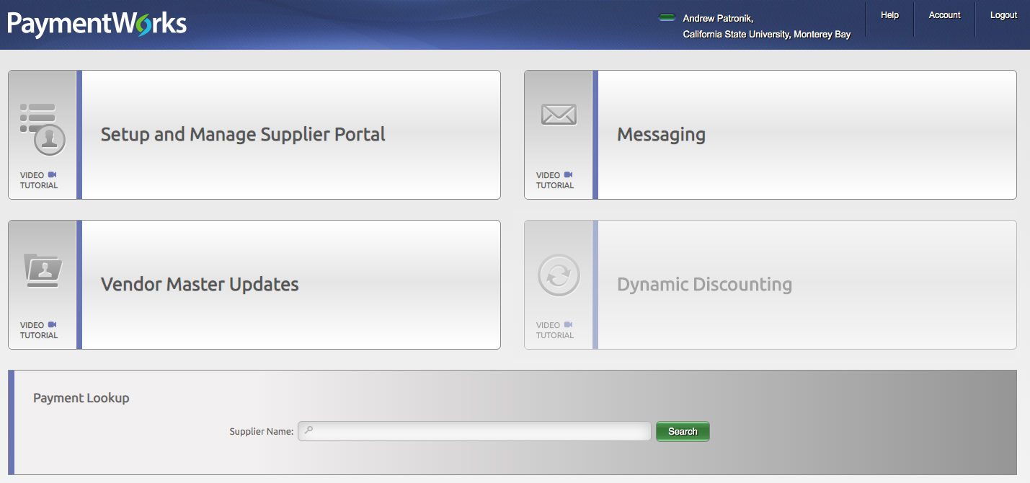

- Then select the tab “New Vendors”

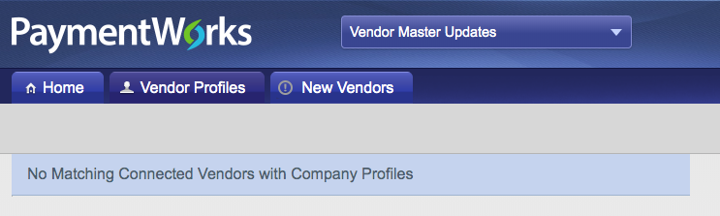

- Click the “Send Invitation” button in the lower left

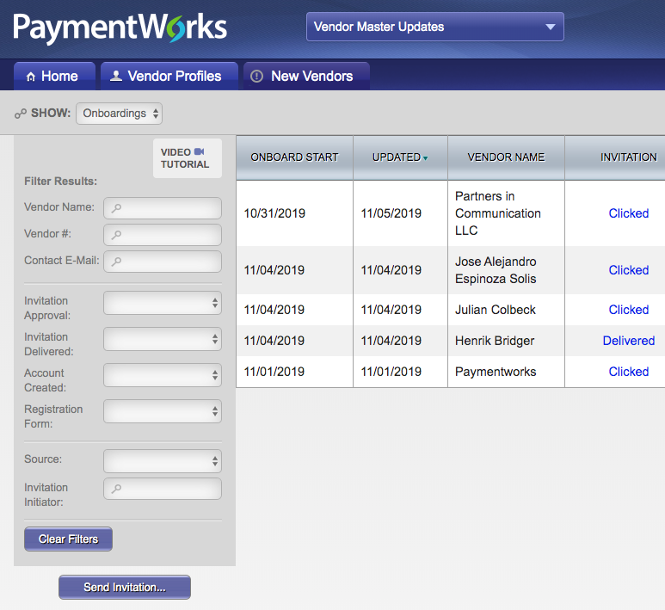

- Enter the vendor’s name and email, as well as your phone number and a brief description of the product or service. Click the “Send” button to email the link directly to the vendor.

Step 3: Monitoring a new vendor’s set-up within PaymentWorks

- New, in-progress, vendors will appear in the “New Vendors” tab and display a % completed progress bar. Be sure to follow-up with vendors who fail to register within PaymentWorks, as it will delay payments.

Searching for Existing Vendors

Vendors already in PaymentWorks can be viewed to verify remit addresses and vendor ID numbers.

- From the Home screen click “Setup and Manage Supplier Portal

- Then go to the “Suppliers” tab to access the full list of vendors and search for specific ones.

